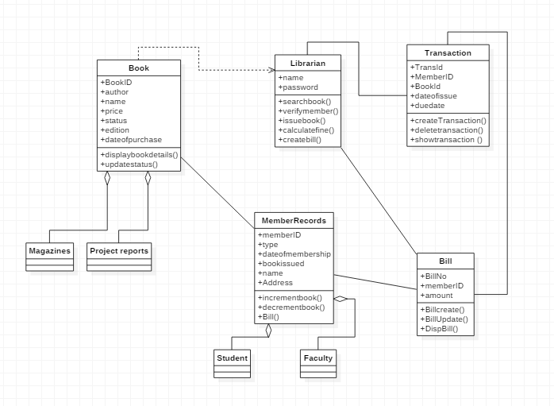

import java.util.*;

/**

*

*/

public class Bill {

/**

* Default constructor

*/

public Bill() {

}

/**

*

*/

public void BillNo;

/**

*

*/

public void memberID;

/**

*

*/

public void amount;

/**

*

*/

public void Billcreate() {

// TODO implement here

}

/**

*

*/

public void BillUpdate() {

// TODO implement here

}

/**

*

*/

public void DispBill() {

// TODO implement here

}

}

**BOOKS:**

**import java.util.*;**

**/\*\***

**\***

**\*/**

**public class Book {**

**/\*\***

**\* Default constructor**

**\*/**

**public Book() {**

**}**

**/\*\***

**\***

**\*/**

**public void BookID;**

**/\*\***

**\***

**\*/**

**public void author;**

**/\*\***

**\***

**\*/**

**public void name;**

**/\*\***

**\***

**\*/**

**public void price;**

**/\*\***

**\***

**\*/**

**public void status;**

**/\*\***

**\***

**\*/**

**public void edition;**

**/\*\***

**\***

**\*/**

**public void dateofpurchase;**

**/\*\***

**\***

**\*/**

**public void displaybookdetails() {**

**// TODO implement here**

**}**

**/\*\***

**\***

**\*/**

**public void updatestatus() {**

**// TODO implement here**

**}**

**}**

**import java.util.*;**

**/\*\***

**\***

**\*/**

**public class Faculty {**

**/\*\***

**\* Default constructor**

**\*/**

**public Faculty() {**

**}**

**}**

**import java.util.*;**

**/\*\***

**\***

**\*/**

**public class Librarian {**

**/\*\***

**\* Default constructor**

**\*/**

**public Librarian() {**

**}**

**/\*\***

**\***

**\*/**

**public void name;**

**/\*\***

**\***

**\*/**

**public void password;**

**/\*\***

**\***

**\*/**

**public void searchbook() {**

**// TODO implement here**

**}**

**/\*\***

**\***

**\*/**

**public void verifymember() {**

**// TODO implement here**

**}**

**/\*\***

**\***

**\*/**

**public void issuebook() {**

**// TODO implement here**

**}**

**/\*\***

**\***

**\*/**

**public void calculatefine() {**

**// TODO implement here**

**}**

**/\*\***

**\***

**\*/**

**public void createbill() {**

**// TODO implement here**

**}**

**}**

**import java.util.*;**

**/\*\***

**\***

**\*/**

**public class Magazines {**

**/\*\***

**\* Default constructor**

**\*/**

**public Magazines() {**

**}**

**}**

**import java.util.*;**

**/\*\***

**\***

**\*/**

**public class MemberRecords {**

**/\*\***

**\* Default constructor**

**\*/**

**public MemberRecords() {**

**}**

**/\*\***

**\***

**\*/**

**public void memberID;**

**/\*\***

**\***

**\*/**

**public void type;**

**/\*\***

**\***

**\*/**

**public void dateofmembership;**

**/\*\***

**\***

**\*/**

**public void bookissued;**

**/\*\***

**\***

**\*/**

**public void name;**

**/\*\***

**\***

**\*/**

**public void Address;**

**/\*\***

**\***

**\*/**

**public void incrementbook() {**

**// TODO implement here**

**}**

**/\*\***

**\***

**\*/**

**public void decrementbook() {**

**// TODO implement here**

**}**

**/\*\***

**\***

**\*/**

**public void Bill() {**

**// TODO implement here**

**}**

**}**

**import java.util.*;**

**/\*\***

**\***

**\*/**

**public class Student {**

**/\*\***

**\* Default constructor**

**\*/**

**public Student() {**

**}**

**}**

**import java.util.*;**

**/\*\***

**\***

**\*/**

**public class Transaction {**

**/\*\***

**\* Default constructor**

**\*/**

**public Transaction() {**

**}**

**/\*\***

**\***

**\*/**

**public void TransId;**

**/\*\***

**\***

**\*/**

**public void MemberID;**

**/\*\***

**\***

**\*/**

**public void BookId;**

**/\*\***

**\***

**\*/**

**public void dateofissue;**

**/\*\***

**\***

**\*/**

**public void duedate;**

**/\*\***

**\***

**\*/**

**public void createTransaction() {**

**// TODO implement here**

**}**

**/\*\***

**\***

**\*/**

**public void deletetransaction() {**

**// TODO implement here**

**}**

**/\*\***

**\***

**\*/**

**public void showtransaction () {**

**// TODO implement here**

**}**

**}**

**import java.util.*;**

**/\*\***

**\***

**\*/**

**public class Project reports {**

**/\*\***

**\* Default constructor**

**\*/**

**public Project reports() {**

**}**

**}**